**Reports Using Report Ng**

**Add the below dependencies from maven repository**

**Pom.xml file**

<!--ReportNG-->

<dependency>

<groupId>org.uncommons</groupId>

<artifactId>reportng</artifactId>

<version>1.1.4</version>

<scope>test</scope>

</dependency>

<!--velocity-dep 1.4-->

<dependency>

<groupId>velocity</groupId>

<artifactId>velocity-dep</artifactId>

<version>1.4</version>

</dependency>

<!--Guice 3.0-->

<dependency>

<groupId>com.google.inject</groupId>

<artifactId>guice</artifactId>

<version>3.0</version>

</dependency>

**Goto> project>rightclick on it>testNg**

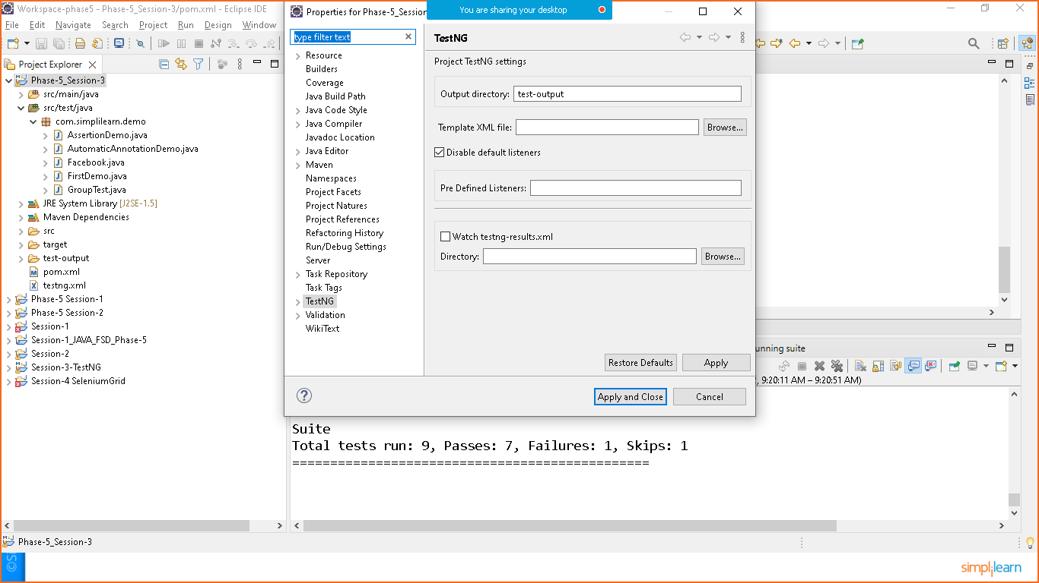

**Testng.xml**

<?xml version=*"1.0"* encoding=*"UTF-8"*?>

<!DOCTYPE suite SYSTEM "https://testng.org/testng-1.0.dtd">

<suite name=*"Suite"*>

<listeners>

<listener class-name=*"org.uncommons.reportng.HTMLReporter"*/>

<listener class-name=*"org.uncommons.reportng.JUnitXMLReporter"*/>

</listeners>

</suite> <!-- Suite -->

**Rightclick on project> maven>update**

**Now goto testng.xml>Run as testNgSuit**

**Once the all testcases will executes here, you need to refresh the project folder**

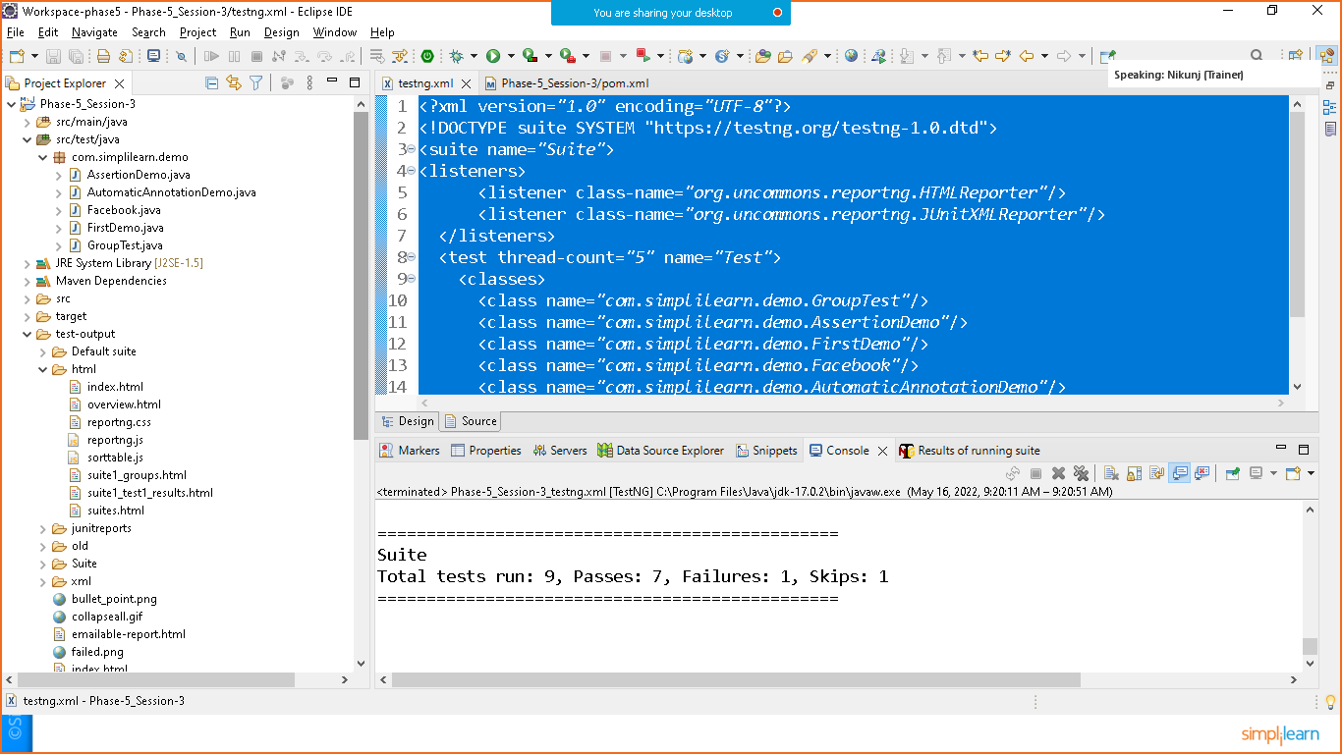

**You will see html folder generated inside test-output folder**

**Goto>html>index.html**

**Open with web browser**

